MBA 576

Adv Predictive Models

Project Report on

Adding Additional Vocabulary to pre-built machine

Submitted by
George Peter : UIN - 659371163
Summary of the Project

This project aims to inherit a model fully learned and extend it to consume a completely new set of words. The process involves the following high level steps

- Train a standard chatbot model on text X. For this example, we have used data from movie dialogues
- Construct a dataset Y completely different from X. For this example, we have developed Y using stackoverflow discussions
- Augment the chatbot machine saved from step 1 using dataset Y
- Test the results of new model by validating if the model is capable of executing words from both Text X and Text Y

Motivation : Real world applications of this approach

Business application of this project is primarily oriented towards closed chat systems based on current understanding of the chatbot model. As an example consider chatting platforms used in specialized stock trading systems, where new words are added on a regular basis such as new ticker symbols.

It is difficult to retrain models in its entirety from scratch for additional words. Therefore, a more cost effective model would be to figure out an approach of augmenting the vocabulary and enhance the models to accommodate the new vocabulary.

References

This project is built using the base code base available at :
https://pytorch.org/tutorials/beginner/chatbot_tutorial.html?highlight=chatbot

Stackoverflow scraping logic was utilized from the following location :
https://melaniesoek0120.medium.com/stack-overflow-web-scraping-with-python-2a1931ed2bd5

Introduction to Seq to Seq models
https://www.linkedin.com/pulse/explanation-attention-based-encoder-decoder-deep-keshav-bhandari/

Background on Chatbot design

Chatbots are engineered to identify the inherent relationship between word sequences based on the text they are trained on. Given below are the fundamental elements of a chatbot machine

- Vocabulary Object : Contains a list of all words, the position of each word in this list offers an important correlation to other objects that are used in defining the Chatbot. Each word would get a numerical index using this object.

- Embedding Object : Contains a matrix encoded and trained from word indices (indices generated from Vocabulary object). Each word is represented by a vector in the matrix. If the vector is close to another, then those words are semantically close.

- Encoder Object : network that accepts each input and generates an intermediate vector representation of each input sequence. Encode is trained along with / alongside the decoder.

- Decoder Object : accepts the output of encoder and predicts words based on the original input sequence. The decoder starts predicting the next word based on the intermediate vector produced by the encoder.

Given below is a mapping of each object / component of the chatbot architecture used in this project with its mapping to the core components noted above.

Object | Class Name | Comments
Vocabulary | Voc | Includes logic to parse sentences to add words
Embedding | Multiple embedding objects | Embedding is saved as part of the model to the disk for the original movie word vocabulary. Stackoverflow based embedding is initialized as part of the logic
Encoder | EncoderRNN | No changes from original baseline
Decoder | LuongAttnDecoderRNN | No changes from original baseline

Input Data

There are two separate sets of input utilized for training this model

Group 1 : Movie dialogues

This set of lines represent the original input sequences provided along with the code for training the model. Sentences in the training data represent dialogues between movie characters as a statement (by a character in the movie) and its response. Given below is an example set

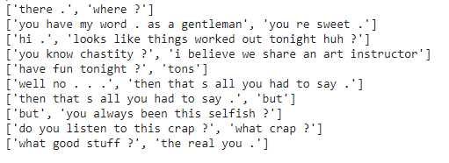

Group 2 : Stackoverflow chats

These lines were procured by scraping questions and answers from stackoverflow. The words used here are quite different from Group 1 both in terms of the vocabulary used and the ideas communicated. Here are some examples. Size of this group is kept intentionally small to enable a faster training cycle for the new model.

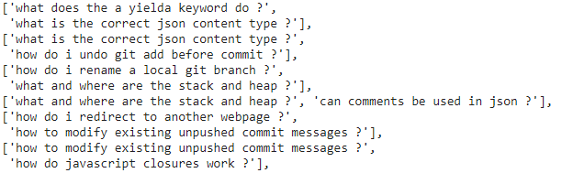

A key consideration here is that the two sets are entirely different from each other. This can be seen in the scatter plot of the word embedding matrix corresponding to the combined vocabulary.

Project Steps

Step 1 : Train the chatbot for original Input Data

The train process was executed as originally coded in the chatbot architecture for a total of 4000 training iterations. The resulting ML Model is saved into the disk with the following objects

- 'iteration': iteration,
- 'en': encoder.state_dict(),
- 'de': decoder.state_dict(),
- 'en_opt': encoder_optimizer.state_dict(),
- 'de_opt': decoder_optimizer.state_dict(),
- 'loss': loss,
- 'voc_dict': voc.__dict__,
- 'embedding': embedding.state_dict()

Step 2 : Generate StackOverflow training data

The logic implemented to generate this portion of data involves scraping the stack overflow lines from the following URL

https://stackoverflow.com/questions?tab=votes&page=?sort=votes&pagesize=50

It generates 50 items per URL invocation. The logic converts resulting items on the page response and scrapes the items into the format of the data set that was used in the chatbot program.

Step 2 : Load the encoder and decoder from saved objects
The new vocabulary object has increased in size given the new words we are looking to add. Therefore the original encoder and decoder objects will not match with the new vocabulary object. To address this problem, we create the encoder and decoder using the original (movie dialogue) vocabulary object. With this baseline we can now load the encoder and decoder from saved objects.

Step 3 : Create a merged vocabulary and embedding

Vocabulary :
- Read each line and its response from movie data set
- Parse the lines to dissect the words and add to VOC object
- Read the stackoverflow data set
- Parse the lines from stackoverflow data set and add the words to main VOC object
Our code holds a total of 3 VOC objects to identify the vocab of each individual dataset and a combined one.

Embedding :
- Load the embedding from saved objects representing original movie data set
- Generate a new embedding object based on the VOC of stackoverflow data set

It is important to hold the relative position of words in the VOC vector and (corresponding) embedding vector as we recreate the objects. This correlation must be maintained to avoid disrupting the vectors learned as part of the training process into the embedding objects.

Step 4 : Reset embedding object of encoder and decoder

We now have the new merged embedding object that combines the full vocabulary of movie lines and stack overflow text. So we now set the inherent embedding of the encoder and decoder to this new embedding object.

Step 5 : Train a new model using updated objects

A second round of training is executed using the combined vocabulary and merged Embedding object. This second training executes a significant decrease in the training time give that it is parsing a much smaller data set in stack overflow

Comparing the data set

Item | Movie | Stack
Total Data | 221282 Sentence pairs | 150 Sentence pairs
Words | 18008 words | 66 words

Merged vocabulary size : 18031
Comparing Training Iterations

Item | Move | Stack
Time taken | 9990 Seconds | 160 seconds
No of iterations | 4000 | 4000

Loss

Original code with movie only | Updated data set with stack and movie
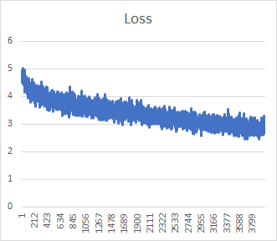 | 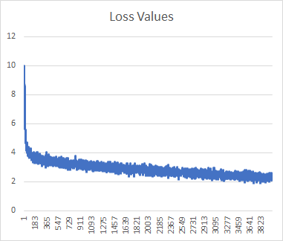

Comparison of Results

Sample response from bot  (as per the original author) | Sample response from bot  (after we loaded the objects from saved model, but did not train further) | Sample response from bot  After merging the vocab and retraining 4000 more iterations
hello?  Bot: hello .  where am I?  Bot: you re in a hospital .  who are you?  Bot: i m a lawyer .  how are you doing?  Bot: i m fine .  are you my friend?  Bot: no .  you're under arrest  Bot: i m trying to help you !  i'm just kidding  Bot: i m sorry .  where are you from?  Bot: san francisco .  it's time for me to leave  Bot: i know .  goodbye  Bot: goodbye . | > hello?  Bot: hello . . . . .  > where am I?  Bot: lennox . . . . .  > where am I?  Bot: lennox . . . . .  > where am I?  Bot: lennox . . . . .  > where am I?  Bot: lennox . . . . .  > who are you?  Bot: i m martha to the bathroom . .  > how are you doing?  Bot: fine . . . . .  > are you my friend?  Bot: yes . . . . .  > are you my friend?  Bot: yes . . . . .  > you're under arrest  Bot: i m not sure . . .  > i'm just kidding  Bot: you re not going to be polite  > where are you from?  Bot: southern . . . . .  > it's time for me to leave  Bot: i m going to get out of here .  > bye  Bot: bye . . . . . | > hello?  Bot: it s me . . . . .  > where am I?  Bot: you re the new field . . .  > who are you?  Bot: i m the girl . . .  > how are you doing?  Bot: i m fine . . . ?  > are you my friend?  Bot: yes . . . . .  > you're under arrest  Bot: you know what i am . .  > i'm just kidding  Bot: stressed ! ! ! ! !  > where are you from?  Bot: kham holiness . . . .  > it's time for me to leave  Bot: it s not what you want .  > tell me about python  Bot: i m sorry . . . .  > rename a local git branch  Bot: and what are you talking about ? ?  > where are the stack  Bot: i m a girl . ? ?  > change the heap for me  Bot: i m sorry . . . .  > difference between 'git pull' and 'git fetch  Bot: i m not gonna die here . .  > yield keyword in Python  Bot: i m not gonna see you again .

Some Conclusions

- We are able to match the original model output at the start of the training process for combined vocabulary
- As we train with combined vocabulary, our accuracy levels continues steady for the original vocabulary and improves on the new vocabulary

